W9 - PRACTICE
FIREBASE (REST API)

 Learning objectives
- Fetch data from Firebase REST API and transform data with DTO
- Use POST or PATCH or PUT to update the Firebase data
- Handle a JOIN on 2 collections, using various approaches
- Handle a CACHE on REPOSITORIES

How to start?
- Copy the START CODE into your current repository and push it
W9 - Start Code

- Each task of this practice shall be related to commit(s) including the tasks ID.
W9 -01 – Fetch and display songs

How to submit?
- Once finished, submit on MS Team
  - Your GitHub repository URL
  - This document if needed



This practice focusses more on clean code structure rather than Flutter technical skills.
We will evaluate how well you follow the coding conventions, how your name your class, variables etc.

No code generated by AI is allowed

W9-01 – Fetch and display songs in the library screen

⚠️ Before starting this practice, you must have created your W9-DATABASE on Firebase with the right settings (rules…)

The start code is provided with a JSON file to be imported to your firebase realtime database

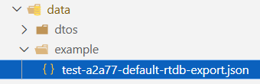
JSON data to import to your Firebase database

Refactor existing code
The JSON data does not exactly match with the current model/Song class.
As example, we don’t store the artist’s name but its ID.

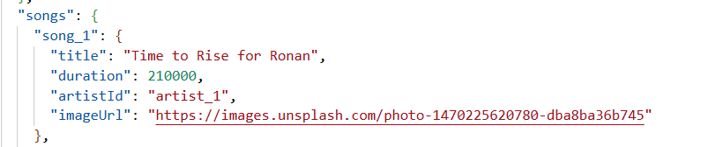

TODO
- Adapt the Song class in the /model accordingly
- Adapt the SongDTO accordingly
- Adapt the SongRepositoryFirebase
Tip: The fetched data is not anymore, a List<dynamic> but a Map<String, dynamic>

- Adapt the View to display the image
Tip: Use a CircleAvatar with a NetworkImage to display the image from URL

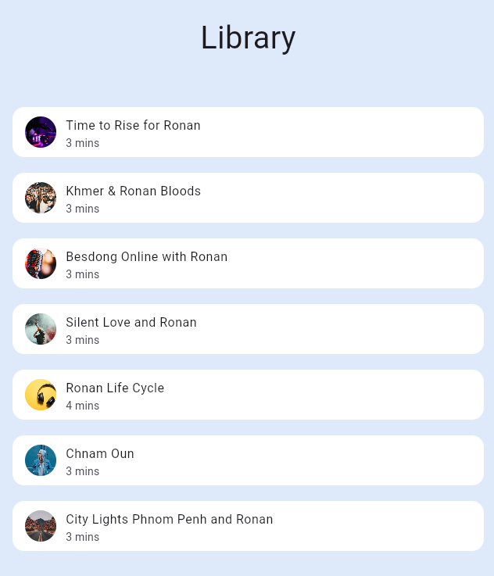

W9-02 – Fetch and display artists in the Artist screen

Follow the same approach to fetch artists and display them in a new view

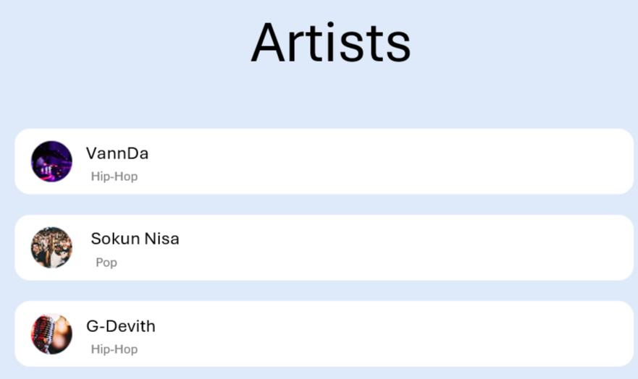

TODO
- Implement the MODEL
- Implement the DTOS
- Implement the REPOSITORIES
- Inject the REPOSITORY to the main
- Create the Artists screen, model view and content
- Fetch the artists within the model view
- Display artist within an artist tile in the content

W9-03 – Join the Song with Artist to display rich Song information

We want now to display more information about the Artist on the Song Tile, as shown bellow:

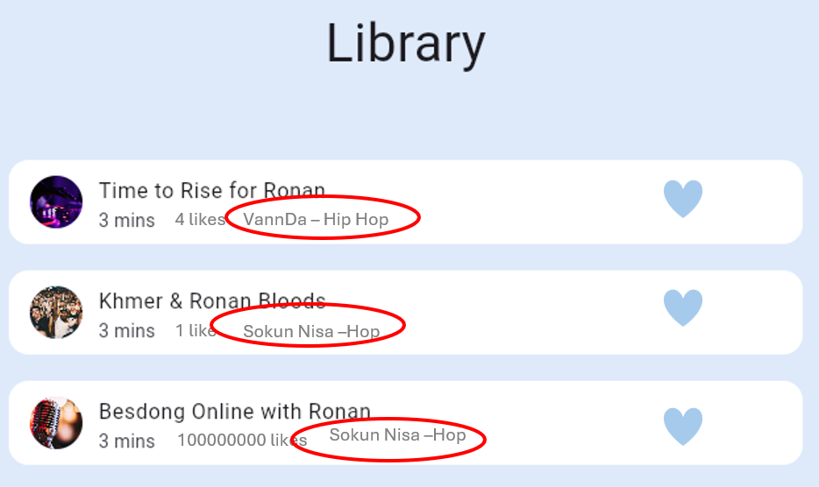

❓ Where do you want to join the song and the artist collections? Repository? View Model? An additional Service?
I want to join both a song an artist inside the view model by passsing the artistReposiory inside the library view model

❓ How to you want to store the Song additional information (artist name, artiste genre…)?
While in song there a artist id that refer to that id the information when fetch using model is return and pass it to the songtile so the song tile take the artist and song

TODO
- Propose the updated architecture and sequence diagram – Validate it with the lecturer
- Implement your solution if validated

